Ethanol Sensor

Product Number: ENETH105
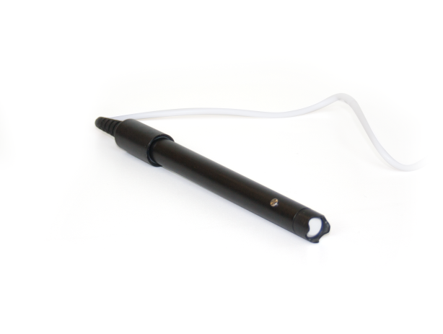

Overview
The Ethanol sensor is an accurate, easy to use, sensor designed to measure ethanol levels in air and is used in experiments having to do with fermentation.

The Ethanol Sensor can be connected to all types of einstein™ data loggers.

Typical experiments



Biology
- Monitoring the fermentation process

Sensor specification
Range: | 0% - 4%
Accuracy: | ±1.5%
Resolution (12-bit): | 12 bit
Temperature Compensation: | Yes
Response Time for 95% of Reading: | 1 minute
Operating Temperature | -10 to 40 °C
Note: sensor cables sold separately

Data logging and analysis

MiLAB™
- Take your einstein™ Tablet or pair your einstein™LabMate™ with your Android or iOS tablet via Bluetooth
- Insert the sensor cable into one of the sensor ports
- Launch MiLAB
- MiLAB will automatically detect the sensor and show it in the Launcher View

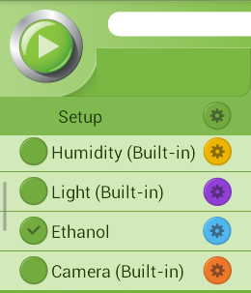

- Check the icon next to the sensor ( ) to enable it for logging

MiLAB™ Desktop
- Pair your einstein™LabMate™ with your PC, MAC, or Linux machine via Bluetooth, or connect it via the USB cable (found in the einstein™LabMate™ box).
- Insert the sensor cable into one of the sensor ports.
- Launch MiLAB.
- MiLAB will automatically detect the sensor and show it in the Current Setup Summary window
- Click Full Setup, located at the bottom of the Current Setup Summary window to program the data logger’s sample rate, number of samples, units of measurement, and other options.
- Click the Run button (  ) on the main toolbar of the Launcher View to start logging.

Maintenance
Changing the Thread seal (Teflon) tape – The tip of the electrode is protected by Thread seal tape. Periodically changing this tape will help improve sensor accuracy.
- To change the tape:
- Remove the blue protective cover
- Unscrew the black screw top cover
- Remove the old tape
- Apply new tape
- Reattach the black screw top
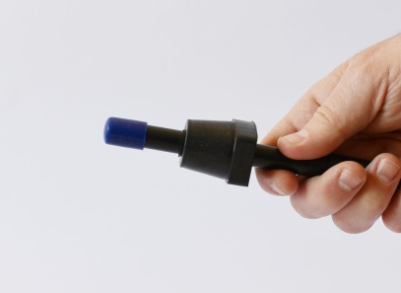 | 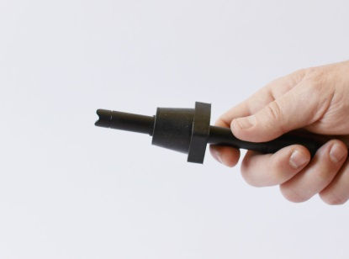 | 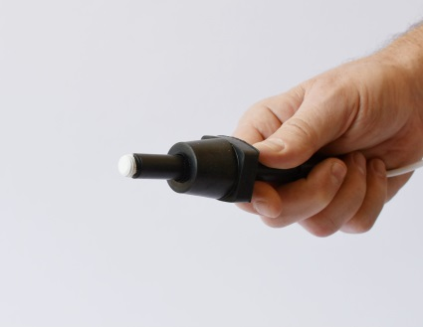

Calibration
The ethanol sensor can be calibrated with either the set zero function of with two point calibration.

Calibrating in MiLAB™
Set Zero Calibration
- Tap the Settings button next to the sensor’s name
- Flip the Set as Zero switch to set the current value as the zero or base value.
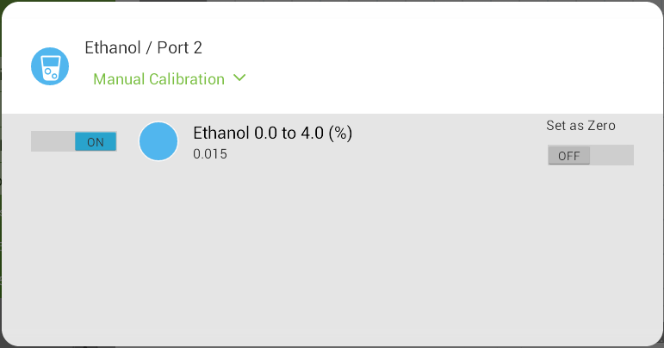
Two Point Calibration
- Tap the Settings button next to the sensor’s name
- Tap Manual Calibration
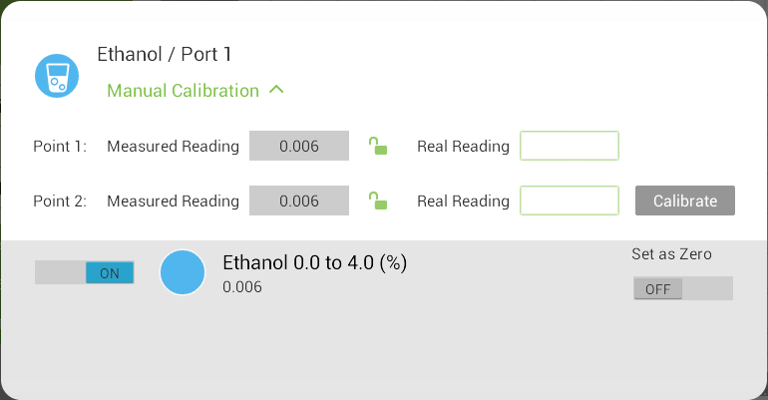
- Prepare a solution with a known value of between 0-4% ethanol. Enter the known value in the Point 1, Real Reading field
- Measure the substance and wait for the readings to stabilize.
- Tap the lock icon 
- Prepare a second solution with a known value of between 0-4% ethanol. Enter this known value in the Point 2, Real Reading field
- Measure the substance and, wait for the readings to stabilize.
- Tap the lock icon
- Tap Calibrate.

Note: For the most accurate results try to calibrate the sensor with one Real Reading under the expected results and one Real Reading over the expected results.

Calibrating in MiLAB™ Desktop
- Go to the Full Setup window and in the Calibrate column click Set
- The Calibration window will appear
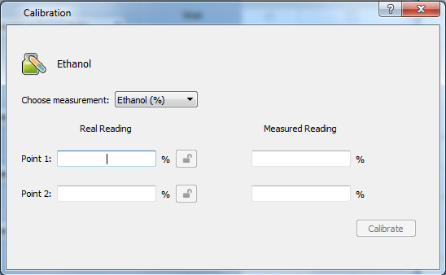
- Prepare a solution with a known value. Enter this known value in the Point 1, Real Reading field
- Measure the substance and, wait for the readings to stabilize.
- Click the lock icon
- Prepare a second substance with a known value. Enter this known value in the Point 2, Real Reading field
- Measure the substance and, wait for the readings to stabilize.
- Click the lock icon
- Click Calibrate
Note: For the most accurate results try to calibrate the sensor with one Real Reading under the expected results and one Real Reading over the expected results.

Experimental set up
The Ethanol Sensor comes with:
- One Ethanol sensor

Note the Ethanol sensor is designed to measure ethanol levels in the air above a solution.

An example of using the Ethanol Sensor
Measuring the ethanol level in air
In this experiment we will measure the ethanol level in the air above an ethanol solution.
Connect the ethanol sensor to a sealed bottle, so you will be able to measure the ethanol concentration inside.

- Partially fill the bottle with water
- Begin measuring the ethanol level
- Add some ethanol to the water
- Follow the changes in the ethanol concentration

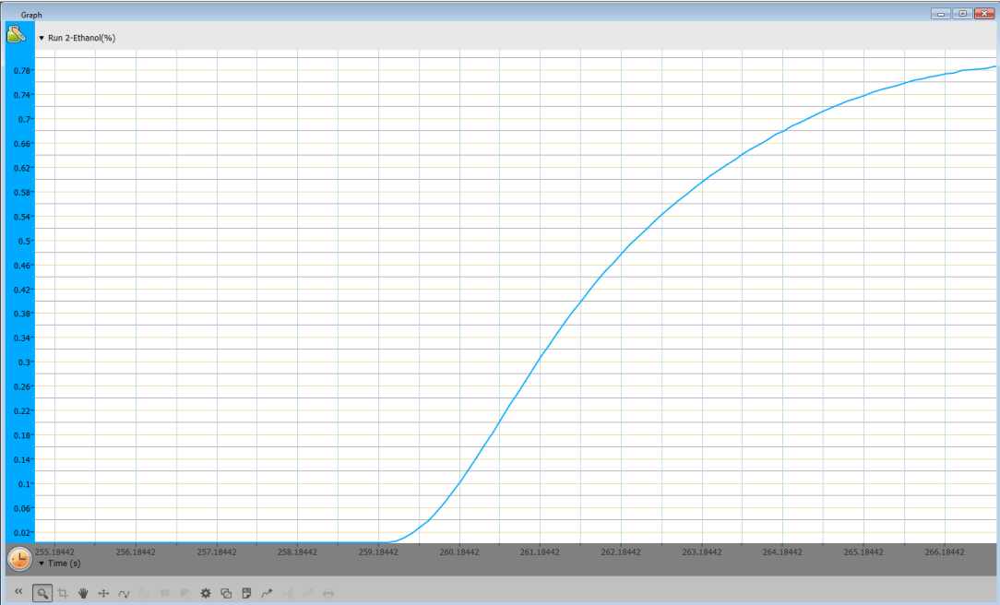
Figure 1. Typical graph produced by this experiment

Troubleshooting
If the Ethanol sensor isn't automatically recognized by MiLAB, please contact Fourier Education's technical support.

Technical support
For technical support, you can contact the Fourier Education's technical support team at:
Web: www.einsteinworld.com/support
Email: support@fourieredu.com
Phone (International): +972-3-901-4849 ext. 232

Copyright and Warranty
All standard Fourier Systems sensors carry a one (1) year warranty, which states that for a period of twelve months after the date of delivery to you, it will be substantially free from significant defects in materials and workmanship.
This warranty does not cover breakage of the product caused by misuse or abuse.
This warranty does not cover Fourier Systems consumables such as electrodes, batteries, EKG stickers, cuvettes and storage solutions or buffers.

©Fourier Systems Ltd. All rights reserved. Fourier Systems Ltd. logos and all other Fourier product or service names are registered trademarks or trademarks of Fourier Systems. All other registered trademarks or trademarks belong to their respective companies.

ALBERT EINSTEIN and EINSTEIN are either trademarks or registered trademarks of The Hebrew University of Jerusalem. Represented exclusively by Green Light. Official licensed merchandise. Website: einstein.biz

